FOCUS FLOW

System Design Document

Version 1.0 27/02/2026
Table of Contents
- Introduction
  - Purpose of the SDD
- General Overview and Design Guidelines / Approach
  - General Overview
  - Assumptions/Constraints/Risks
    - Assumptions
    - Constraints
    - Risks
- Design Considerations
  - Goals and Guidelines
- System Architecture and Architecture Design
  - Use cases
  - Class diagram
  - Sequence diagram
  - Architectural Pattern
  - High-level architecture
  - Technology stack
  - Database Design
  - Deployment Architecture

- API Documentation

Appendix A: Record of Changes Appendix B: Acronyms

Introduction

Purpose of the SDD
The purpose of this Software Design Document (SDD) is to provide a comprehensive overview of the design and architecture of Focus Flow, an AI-Proctored Examination and Learning Management System.
This document describes the system structure, architectural components, design decisions, and the interactions between different modules of the application.
It provides detailed technical insight into how Focus Flow implements secure exam delivery, integrated coding assessments, AI-based proctoring, and performance analytics.
This document serves as a reference for developers, project guides, testers, and stakeholders involved in the development and deployment of the system.
It ensures a shared understanding of the system’s internal design and supports maintainability, scalability, and future enhancements.

General Overview and Design Guidelines / Approach

General Overview
Focus Flow is designed to provide a secure, unified, and intelligent platform for conducting online examinations and technical assessments.
The system integrates exam delivery, coding evaluation, and AI-based proctoring into a single web application to eliminate the need for multiple fragmented tools.
It aims to ensure academic integrity while maintaining user privacy through client-side processing of proctoring data.
The application follows a client-server architecture, consisting of a web-based frontend, a backend REST API server, and a centralized database system for data storage and retrieval.
The frontend provides an interactive and responsive interface for Students and Instructors to perform their respective activities.
The backend is responsible for authentication, authorization, exam management, question handling, result computation, and storage of proctoring flag events.
The system incorporates a built-in coding sandbox environment that enables students to write and execute code directly within the browser.
Additionally, the AI Proctoring Module operates locally on the client device to monitor suspicious behaviors such as gaze deviation and tab switching. Only generated flag events are transmitted to the backend server for review.
The system is designed to be scalable, secure, modular, and easy to maintain.

Assumptions/Constraints/Risks

Assumptions
• Users will have access to a modern web browser such as Chrome, Edge, or Firefox.
• Students attempting proctored examinations will have a functional webcam enabled on their device.
• Users will have a stable internet connection throughout the examination session.
• Educational institutions deploying the system will provide necessary infrastructure support for hosting and maintenance.
• The client device will have sufficient processing capability to execute the AI-based proctoring module locally.

Constraints
• The system must support a large number of concurrent users during peak examination periods.
• The AI proctoring module must operate entirely on the client side to preserve user privacy and reduce server load.
• The development timeline is constrained by academic project deadlines.
• The application must be compatible with modern web browsers and responsive across multiple device screen sizes.
• The system will be developed using the following technologies:
o Frontend: React.js, Bootstrap 5
o Backend: Node.js, Express.js
o Database: MongoDB Atlas
o AI Module: MediaPipe (Client-Side Processing)
• The system depends on the following external libraries and frameworks:
o Passport.js: Authentication middleware for secure session handling
o Monaco Editor: Integrated browser-based coding environment
o MediaPipe: Machine learning framework for client-side proctoring

Risks
• High concurrent usage during examination periods may impact server performance and response time.
• Client-side AI processing may produce false positives in detecting suspicious behavior.
• Network interruptions during an active exam session may disrupt submissions or data synchronization.
• Browser compatibility issues may affect webcam access or coding sandbox functionality.
• Improper configuration of authentication mechanisms may expose security vulnerabilities.

Design Considerations

Goals and Guidelines
The design of the application is guided by the following goals and guidelines:
    - User-Friendly Interface: The application should have an intuitive and easy-to-use interface for users to navigate through quizzes, submit answers, and view results.
    - Scalability: The application should be designed to handle a large number of concurrent users without compromising performance.
    - Security: The application should implement appropriate security measures to protect user information and prevent unauthorized access.
    - Reliability: The application should be robust and resilient, ensuring minimal downtime and data loss.
    - Performance: The application should be optimized for efficient data processing, minimizing response times and resource utilization.
    - Modularity: The system should be designed with modular components to promote code reusability, maintainability, and extensibility.

System Architecture and Architecture Design
• The system architecture of Focus Flow follows a modular and component-based design to fulfil its primary responsibilities, including user authentication, exam management, AI-based proctoring, coding evaluation, data storage, and result generation.
• The system is decomposed into multiple components and subsystems, each responsible for a specific functional domain. These components interact through well-defined interfaces to ensure scalability, maintainability, and security.
• User Interface Component:
The User Interface (UI) component provides a responsive and interactive web interface for Students and Instructors. It manages user input, renders exam questions, displays coding interfaces, and presents analytics dashboards. The UI communicates with the backend through RESTful API calls.
• Authentication and Authorization Component:
This component manages secure user login, registration, session handling, and role-based access control. It ensures that only authorized users can access exam creation, exam participation, and administrative features.
• Exam Management Component:
The Exam Management component allows Instructors to create, modify, and manage examinations. It handles exam configurations such as timer settings, question selection, and approval workflows. It also coordinates with the Question Bank and Coding Sandbox components.
• Question Bank Component:
The Question Bank component stores and manages multiple-choice and coding questions. It supports categorization, difficulty tagging, and retrieval of questions for exam creation.
• Coding Sandbox Component:
The Coding Sandbox component integrates a browser-based code editor that allows Students to write and execute code during technical assessments. It supports syntax highlighting and controlled execution environments.
• AI Proctoring Component:
The AI Proctoring component operates locally on the client device using machine learning models. It monitors user behavior such as gaze direction and tab switching. Instead of transmitting video data, it generates and sends structured flag events to the backend server for integrity review.
• Data Management Component:
The Data Management component interacts with the database to store user accounts, exam data, responses, flag logs, and analytics records. It ensures persistent storage and maintains data integrity.
• Result Generation Component:
The Result Generation component evaluates student responses, calculates scores, compiles coding results, and generates analytics reports for both Students and Instructors.

Use cases
• Register:
This use case represents the process of user registration in Focus Flow. Users provide required details and create an account to access the system.
• Login:
Users can log in using their registered credentials. This use case enables authenticated access based on assigned roles such as Student or Instructor.
• Logout:
Users can securely log out of their accounts, terminating active sessions.
• Reset Password:
Users who forget their password can initiate the password reset process through secure verification.
• Create Exam:
Instructors can create new examinations by defining exam details such as title, duration, and question configuration.
• Edit Exam:
Instructors can modify existing exams before they are published or started.
• Delete Exam:
Instructors can delete exams that are no longer required.
• Manage Question Bank:
Instructors can add, edit, or delete questions within the question bank. Questions may include multiple-choice or coding-type formats.
• Add Question to Exam:
Instructors can select questions from the question bank or create new questions to include in an exam.
• Start Exam:
Instructors can initiate an exam session, allowing students to participate.
• End Exam:
Instructors can terminate an active exam session.
• Attempt Exam:
Students can participate in an active exam by answering MCQs and solving coding problems within the system.
• Initialize Proctoring Session:
When a student begins an exam, the AI Proctoring module initializes and begins monitoring activity locally.
• Submit Answer:
Students can submit answers for MCQ and coding questions during the exam session.
• Generate Flag Event:
The AI module generates flag events when suspicious behavior such as tab switching or gaze deviation is detected.
• View Results:
Students can view their scores and performance analytics after exam completion.
• View Proctoring Logs:
Instructors can review flag events and integrity logs associated with each exam attempt.
• View Analytics Dashboard:
Students and instructors can access performance insights and comparative analytics.
• Manage Users:
Authorized administrators can manage user roles and permissions within the system.
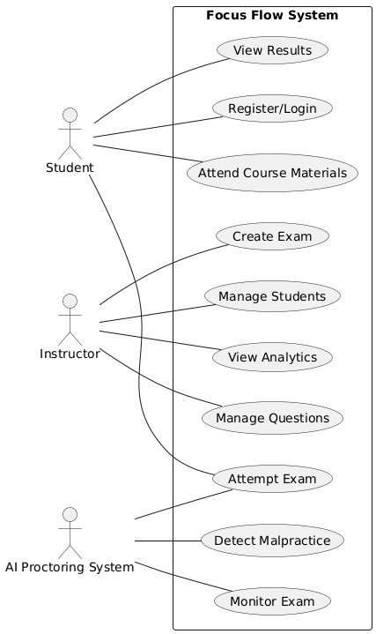
  - Class diagram
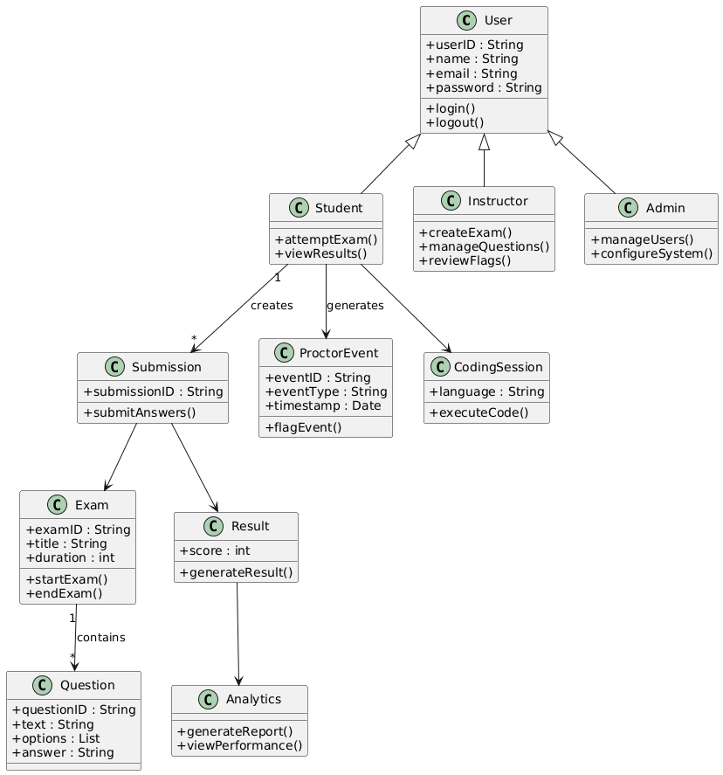
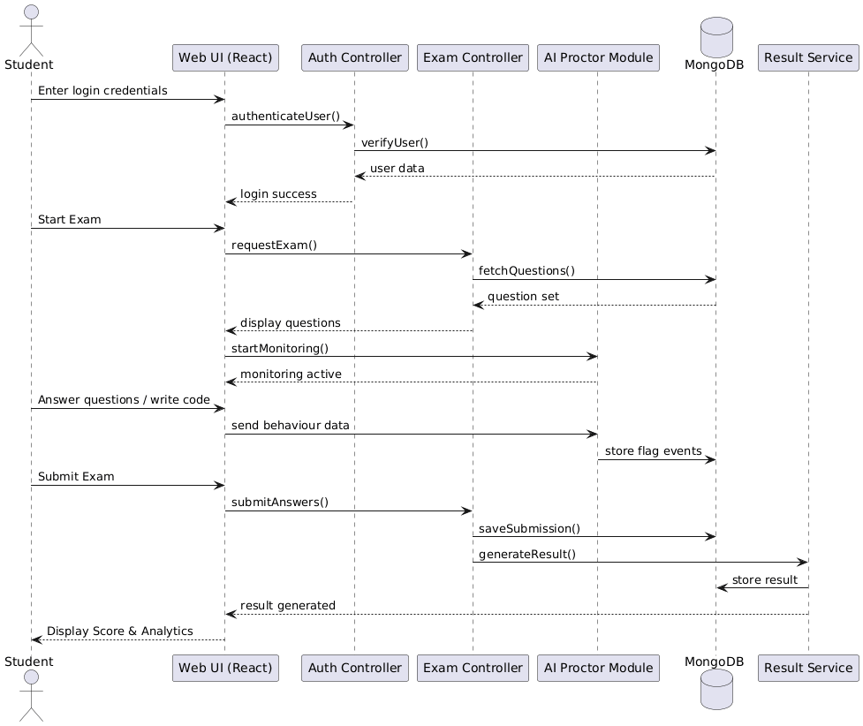
  - Sequence diagrams
  - Architectural Pattern
The Focus Flow application follows the Model-View-Controller (MVC) architectural pattern to ensure separation of concerns and maintain a modular system structure.
This architectural approach divides the application into three primary components:
• Model:
The Model represents the core data and business logic of the system. It includes entities such as Users, Exams, Questions, Responses, Flag Events, and Analytics records. The Model interacts directly with the MongoDB database to perform data storage and retrieval operations.
• View:
The View represents the frontend user interface developed using React.js and Bootstrap. It provides interactive dashboards for Students and Instructors, displays exam content, coding interfaces, analytics graphs, and proctoring status notifications.
• Controller:
The Controller manages user requests and handles communication between the View and the Model. Implemented using Node.js and Express.js, it processes API requests, enforces authentication rules, validates inputs, executes business logic, and returns appropriate responses to the frontend.
The MVC pattern enhances maintainability, scalability, and testability by ensuring that UI components, business logic, and data management remain independent and modular.

High-level architecture

• Focus Flow Web Application:
At the core of the architecture is the Focus Flow Web Application, which serves as the central platform for conducting secure online examinations. It integrates exam delivery, coding evaluation, AI-based proctoring, and analytics within a unified system.
• User Interface Layer:
The User Interface Layer is developed using React.js and provides separate dashboards for Students and Instructors. It handles user interactions such as exam participation, exam creation, viewing results, and managing question banks.
• Authentication and Session Management:
This component manages secure login, registration, and role-based access control using Passport.js. It ensures that only authorized users can access specific system functionalities based on their assigned roles.
• Exam Management Module:
The Exam Management module enables Instructors to create, configure, edit, and manage exams. It controls exam timers, question allocation, and participation permissions.
• Question Bank Module:
The Question Bank acts as a centralized repository of multiple-choice and coding questions. It supports categorization, difficulty levels, and efficient retrieval for exam creation.
• Coding Sandbox Module:
This module integrates a browser-based code editor environment that allows students to write and execute code during exams. It ensures controlled execution and secure submission handling.
• AI Proctoring Module:
The AI Proctoring module operates locally on the client device using machine learning frameworks. It monitors behaviors such as gaze direction and tab switching. Instead of transmitting video streams, it generates structured flag events that are sent to the backend for logging and review.
• Backend API Server:
The Backend Server, built using Node.js and Express.js, processes RESTful API requests from the frontend. It handles authentication, exam logic, question management, response storage, and analytics generation.
• Database Layer:
The Database Layer, implemented using MongoDB Atlas, stores persistent data including user credentials, exams, questions, responses, flag events, and analytics records.
• External Stakeholders:
The system interacts with Students, Instructors, and Educational Institutions who deploy and utilize the application. These external entities access the system through secure web interfaces.
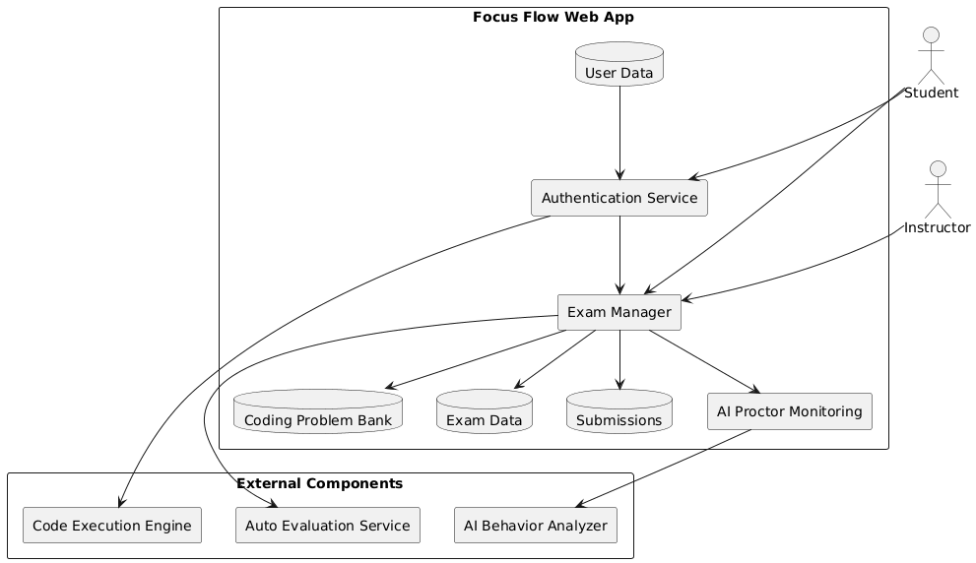
The High-Level Architecture ensures a clear separation between presentation, business logic, AI monitoring, and data storage, promoting scalability, reliability, and maintainability.

Data Flow Diagram

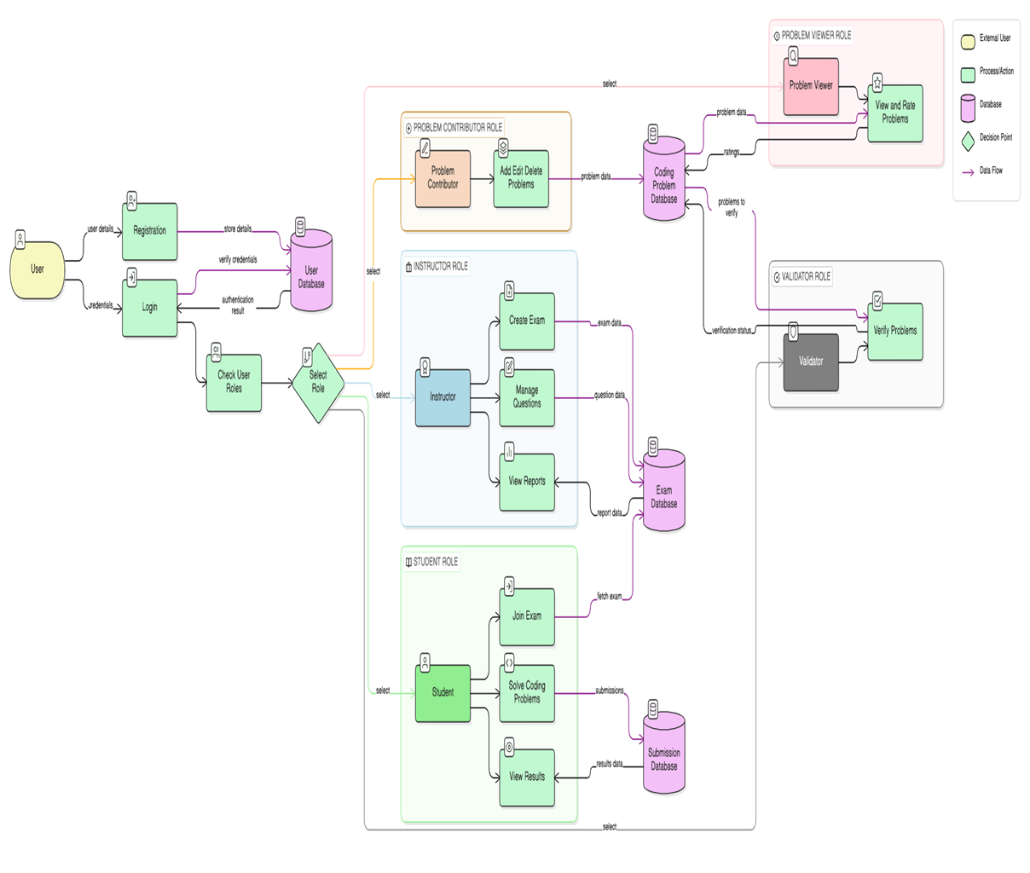
Level 0 DFD:

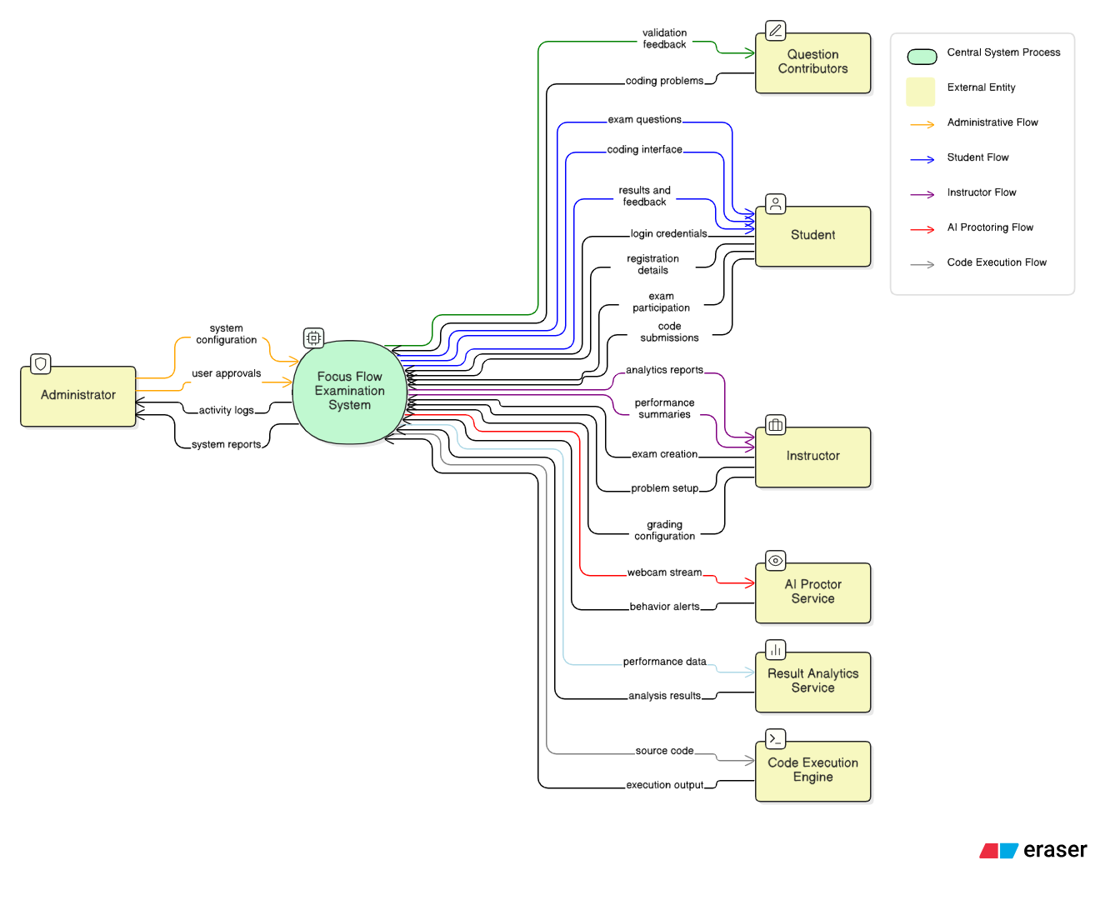

- Level 1 DFDs:

Create Exam
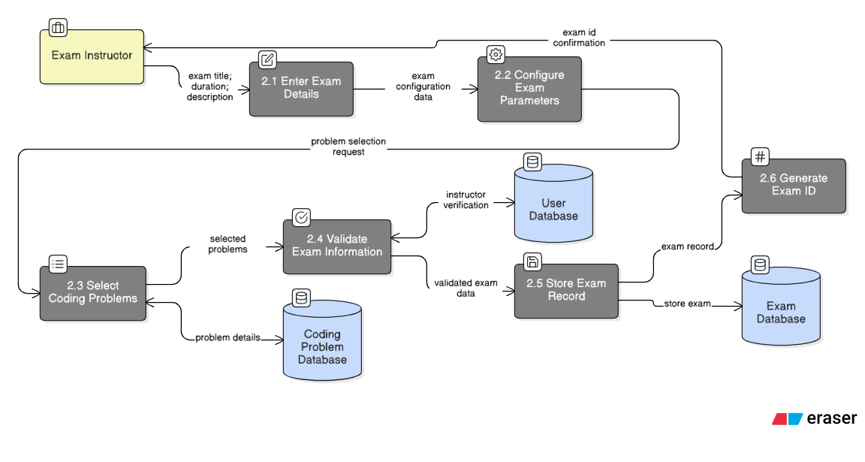

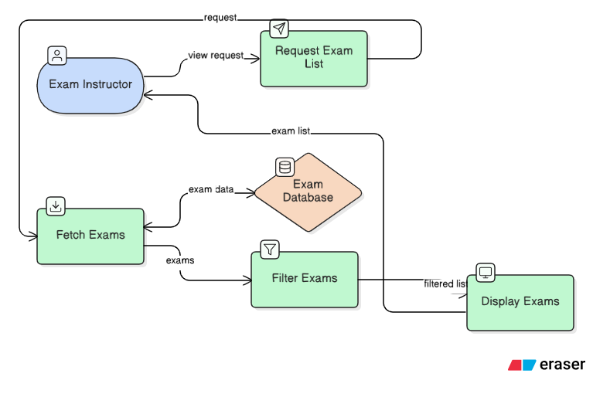
View Exams
Edit Exam
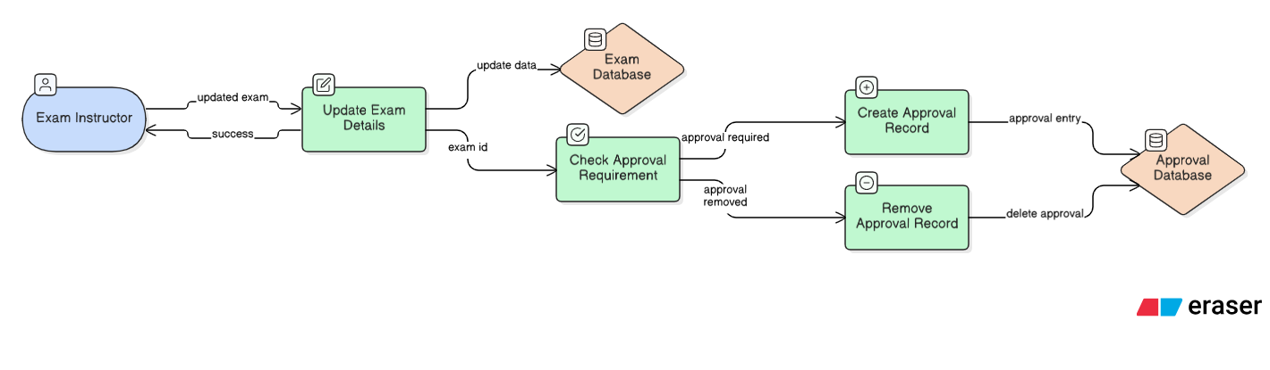

Delete Exam

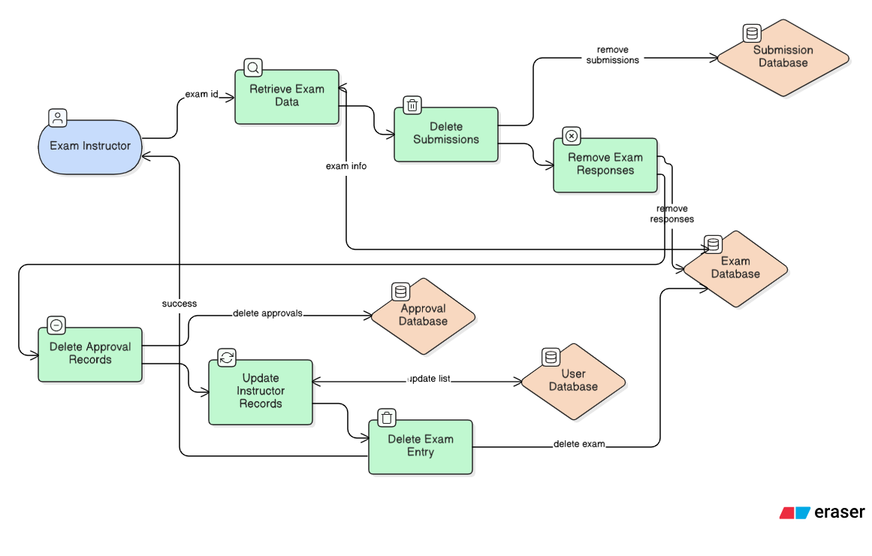
Start, End Exam
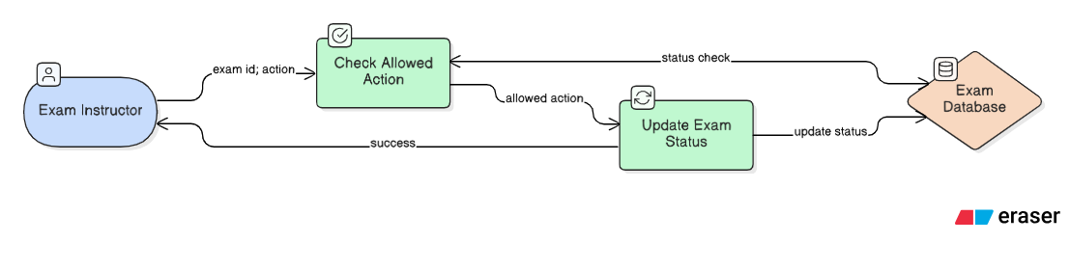

Manage Coding Problems
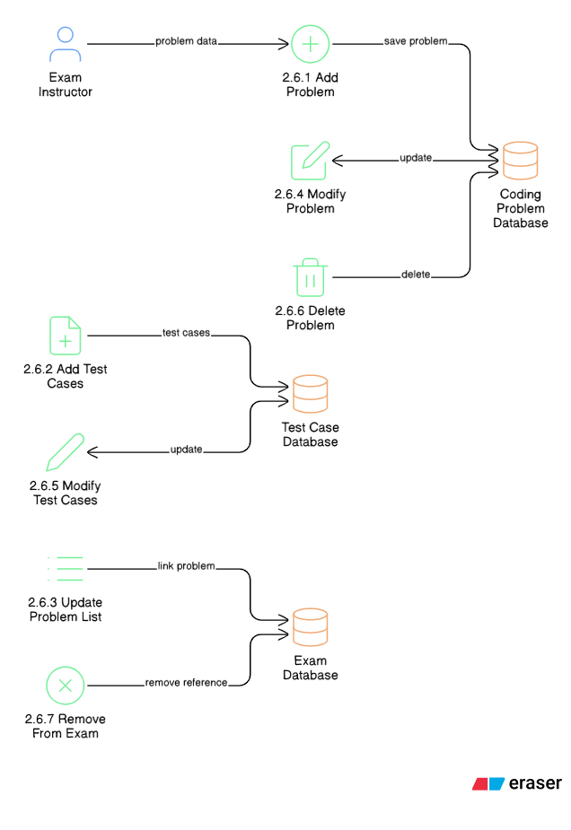
Import From Problem Bank
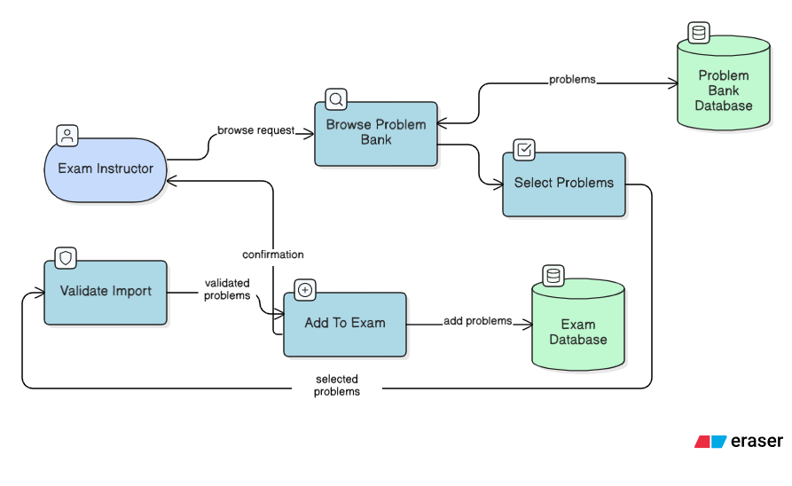

Manage Proctor Flags / Approval

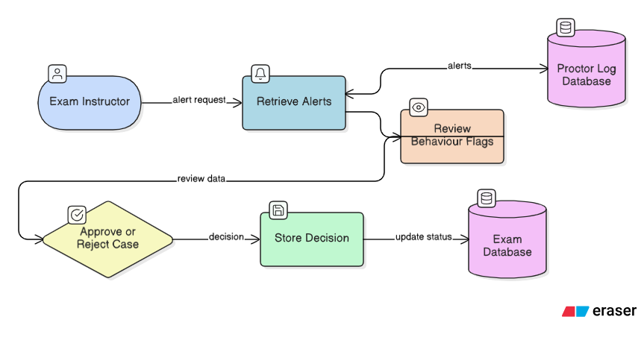

View Submissions And Results

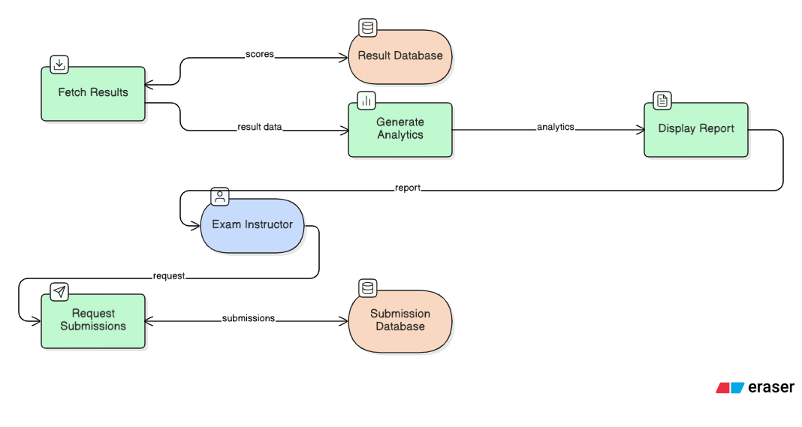

Technology stack
• Operating System:
The Focus Flow application can operate on any modern operating system such as Windows, Linux, or macOS. Since it is a web-based application, it is platform-independent and accessible through standard web browsers.
• Programming Language:
The primary programming language used in the development of the system is JavaScript.
• Frontend Technologies:
o React.js: Used for building dynamic and responsive user interfaces.
o Bootstrap 5: Used for responsive design and consistent UI styling.
o MediaPipe: Used for implementing client-side AI-based proctoring functionalities.
o Monaco Editor: Integrated for browser-based coding sandbox support.
• Backend Technologies:
o Node.js: Provides the runtime environment for server-side execution.
o Express.js: Used for building RESTful APIs and managing routing logic.
o Passport.js: Used for secure authentication and session management.
• Database:
o MongoDB Atlas: A cloud-based NoSQL database used for storing user data, exams, responses, flag events, and analytics information.
• Web Server:
The backend server is hosted using Node.js with Express middleware to handle HTTP requests and responses efficiently.
• Deployment Environment:
The application can be deployed on cloud platforms such as Render, Vercel, or similar hosting services that support Node.js applications and MongoDB connectivity.
The chosen technology stack ensures scalability, modularity, and efficient performance for both academic deployment and potential production-level expansion.
  - Database Design

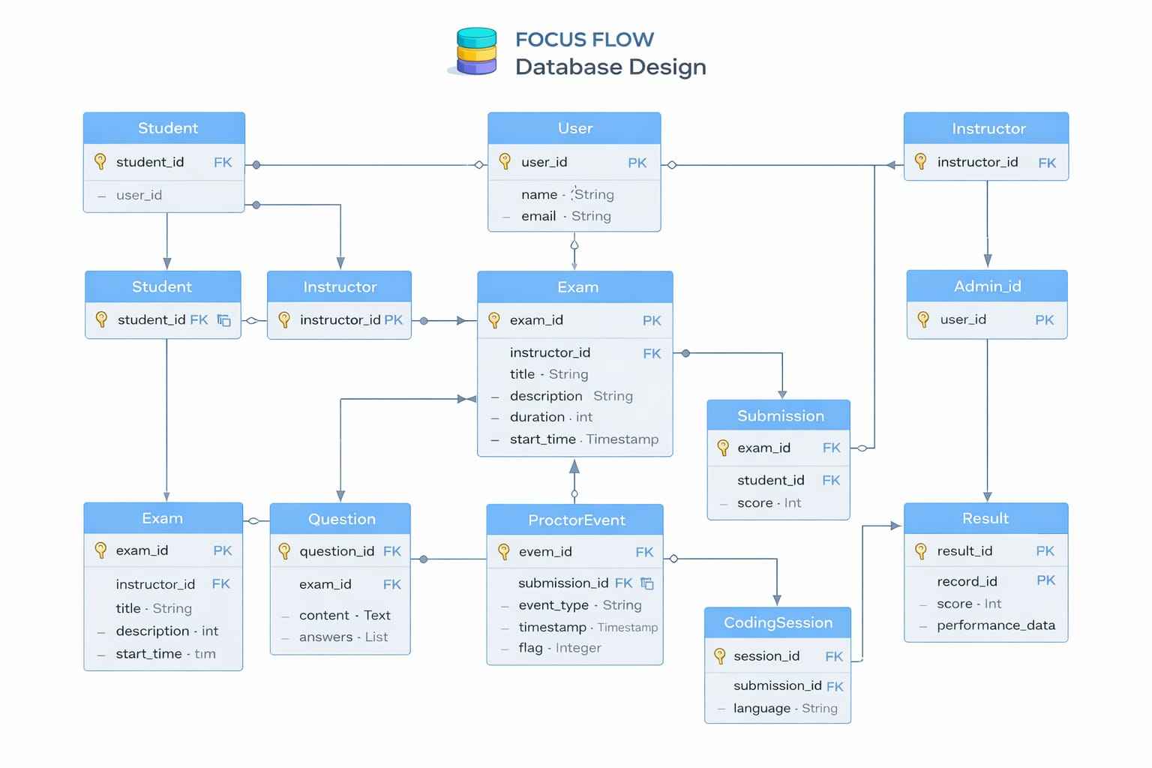
  - Deployment Architecture
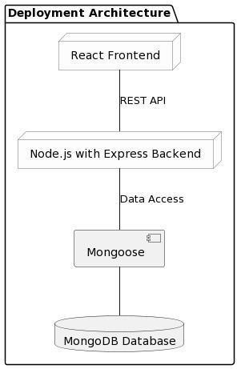

API Documentation

User registration, Login, User Management & Details
- POST /students/add
Data to be sent in the body:
● email (string): The email address of the student. (Password is auto-generated as 'password123' and role is set to 'Student').
Responses:
● 400 Bad Request: Email is required.
● 403 Forbidden: Access denied. Instructors only.
● 409 Conflict: A user with this email already exists.
● 201 Created: Student added successfully.
● 500 Internal Server Error: Failed to add student.
2. POST /auth/login
Data to be sent in the body:
● username (string): The user’s email address (used as username in local strategy).
● password (string): The user’s password.
Responses:
● 401 Unauthorized: Invalid credentials.
● 200 OK: Login successful. Session established and user details returned.
3. GET /auth/session
Data to be sent in cookies:
● Session cookie automatically sent by the browser.
Responses:
● 401 Unauthorized: Not authenticated.
● 200 OK: Returns current user details.
4. POST /auth/logout
Data to be sent in cookies:
● Session cookie.
Responses:
● 500 Internal Server Error: Error logging out.
● 200 OK: Logout successful.
5. POST /auth/forgot-password
Data to be sent in the body:
● email (string): The registered email address of the student.
Responses:
● 400 Bad Request: Email is required.
● 404 Not Found: No student account found with this email.
● 200 OK: Password reset request sent to instructor (returns requestId).
● 500 Internal Server Error: Failed to submit reset request.
6. GET /auth/reset-status/:requested
Responses:
● 404 Not Found: Status not found
● 200 OK: Returns the status of the request (e.g., pending, approved, rejected).
● 500 Internal Server Error: Error checking status.
7. GET /students/reset-requests
Responses:
● 403 Forbidden: Access denied.
● 200 OK: Returns a list of pending reset requests.
● 500 Internal Server Error: Failed to fetch reset requests.
8. POST /students/reset-requests/:id/approve
Responses: ● 403 Forbidden: Access denied.
● 404 Not Found: Request not found or already handled / Student not found.
● 200 OK: Password reset approved. Default password set.
● 500 Internal Server Error: Failed to approve request.
9. POST /students/reset-requests/:id/reject
Responses:
● 403 Forbidden: Access denied.
● 404 Not Found: Request not found or already handled.
● 200 OK: Password reset request rejected.
● 500 Internal Server Error: Failed to reject request.
10. POST /auth/change-password
Data to be sent in the body:
● currentPassword (string): The user's current password.
● newPassword (string): The new password to be set.
Responses:
● 400 Bad Request: Missing parameters or password too short.
● 401 Unauthorized: Current password is incorrect.
● 404 Not Found: User not found.
● 200 OK: Password changed successfully.
● 500 Internal Server Error: Failed to change password.
11. GET /students
Responses:
● 403 Forbidden: Access denied.
● 200 OK: Returns list of all students.
● 500 Internal Server Error: Failed to fetch students.
12. DELETE /students/:id
Responses:
● 403 Forbidden: Access denied.
● 404 Not Found: Student not found.
● 200 OK: Student deleted successfully.
● 500 Internal Server Error: Failed to delete student.

Exam Management

- POST /exams
Data to be sent in the body:
● title (string): The name of the exam.
● description (string): Short description of the exam.
● durationMinutes (number): Duration of the exam in minutes.
● questions (array): Array of question objects (MCQ or Coding).
● published (boolean): Whether the exam is visible to students.
Responses:
● 201 Created: Exam created successfully.
● 500 Internal Server Error: Error creating exam.
2. PUT /exams/:id
Data to be sent in the body:
● title (string, optional): Updated exam title.
● description (string, optional): Updated description.
● durationMinutes (number, optional): Updated duration.
● questions (array, optional): Updated array of questions.
● published (boolean, optional): Updated published status.
Responses:
● 404 Not Found: Exam not found or unauthorized.
● 200 OK: Exam updated successfully.
● 500 Internal Server Error: Error updating exam.
3. DELETE /exams/:id
Responses:
● 404 Not Found: Exam not found or unauthorized.
● 200 OK: Exam deleted successfully.
● 500 Internal Server Error: Error deleting exam.
4. GET /exams
Responses:
● 200 OK: Returns all exams for an instructor.
● 500 Internal Server Error: Error fetching exams.
5. GET /exams/available
Responses:
● 200 OK: Returns available/published exams for students (correct answers automatically stripped).
● 500 Internal Server Error: Error fetching exams.
6. GET /exams/:id
Responses:
● 403 Forbidden: Exam is not available (for students if unpublished).
● 404 Not Found: Exam not found.
● 200 OK: Returns exam details (correct answers stripped for students).
● 500 Internal Server Error: Error fetching exam.
.

Exam Participation & Submission

- POST /submissions
Data to be sent in the body:
● examId (string, required): The ID of the exam.
● answers (array, required): Array of the student's answers/code.
● terminatedByProctor (boolean, optional): Flag indicating if the proctor auto-terminated the exam.
Responses:
● 400 Bad Request: You have already submitted this exam.
● 404 Not Found: Exam not found.
● 201 Created: Exam submitted successfully. Returns score and totalPoints.
● 500 Internal Server Error: Error submitting exam.
.

Code Compilation & Execution
- POST /compile/execute
Data to be sent in the body:
● code (string, required): The source code to execute.
● language (string, optional): The programming language (default: javascript).
● input (string, optional): Standard input to provide to the code.
Responses:
● 200 OK: Returns success status, output, execution time, and memory. Handles compilation errors and timeouts as well.
2. POST /compile/test
Data to be sent in the body:
● code (string, required): The source code to execute.
● language (string, optional): The programming language.
● testCases (array, required): Array of objects containing input and expectedOutput.
Responses:
● 200 OK: Returns parallel test execution results, indicating which test cases passed/failed.

AI Proctoring & Flag Management

- POST /proctor/flag
Data to be sent in the body:
● examId (string, required): The ID of the exam.
● flagType (string, required): Type of violation.
● details (object/string, optional): Additional details regarding the flag event.
Responses:
● 400 Bad Request: examId and flagType are required.
● 201 Created: Flag event logged successfully.
● 500 Internal Server Error: Error logging flag.

2. GET /proctor/:examId
Responses:
● 403 Forbidden: Access denied.
● 200 OK: Returns a list of proctor logs for the given exam.
● 500 Internal Server Error: Error fetching logs.

Result & Analytics Management

- GET /submissions/my-submissions
Responses:
● 200 OK: Returns the student's submissions, scores, and analytics.
● 500 Internal Server Error: Error fetching submissions.
2. GET /submissions/instructor
Responses:
● 403 Forbidden: Access denied.
● 200 OK: Returns all submissions for the instructor's exams.
● 500 Internal Server Error: Error fetching submissions.
3. GET /submissions/instructor/detailed
Responses:
● 403 Forbidden: Access denied.
● 200 OK: Returns detailed per-student analytics and proctor violations.
● 500 Internal Server Error: Error fetching detailed analytics.

Appendix A: Record of Changes

Version Number | Date | Author/Owner | Description of Change
1.0 | 27/02/2026 | Team 14 | Initial Version

Appendix B: Acronyms

Acronym | Literal Translation
HTML | Hyper Text Markup Language
CSS | Cascading Style Sheets

